**ACADEMIC PERFORMANCE ASSISTANT**

USER MANUAL

**Submitted by**:

Abellanosa, Irvin Edison

Tan, Sean Patrick

**Submitted to**:

Sir [Paul John Parreño](https://www.facebook.com/paul.j.parreno?fref=nf)

**Submitted on**:

April 3, 2015

# **SYSTEM OVERVIEW**

* The APA application is a tracking and recording system which caters students to keep track of their subjects and scores.
* The application runs on Ice Cream Sandwich and below.
* End users will navigate through the application using a GUI.
* Users of the system will be students.
* Unregistered users need to sign up for an account to use the application.
* The app allows an end user to view relevant announcements and its subjects.
* The app allows an end user to add a subject/item by undergoing a short procedure.
* The app allows an end user to view/edit his/her scores for the items for each subject.
* The colors used in the announcements, subjects, and items are randomly generated.

# **Login**

Right after the splash screen displays, the login page will show up. On the login page, the user will be asked to input his/her registered id number and password in order to continue.

 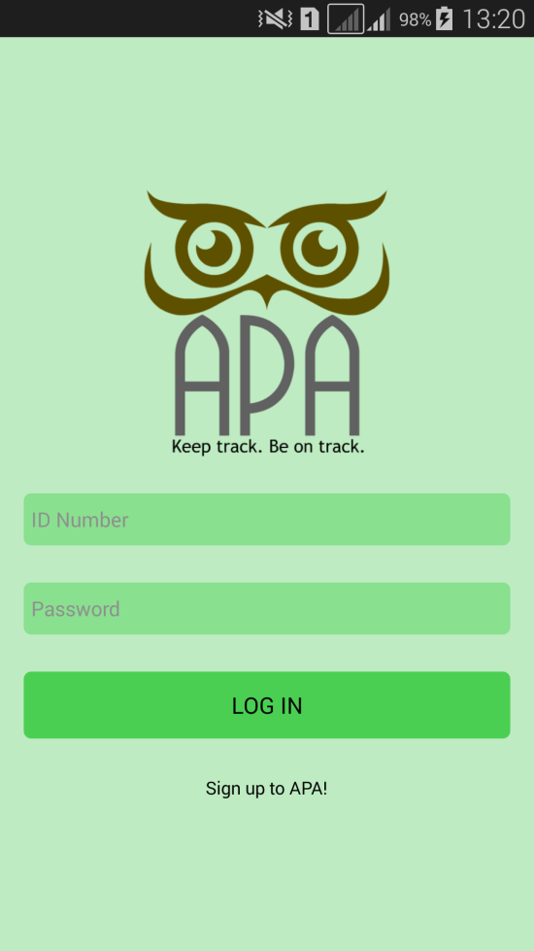

# **Sign Up**

By selecting the “Sign up to APA!” link, you will be redirected to the Registration page after clicking the link.

Supply all forms with the required data. This will be used for identification.

After supplying all the required data and pressing the Submit button, you will be redirected to the login page.

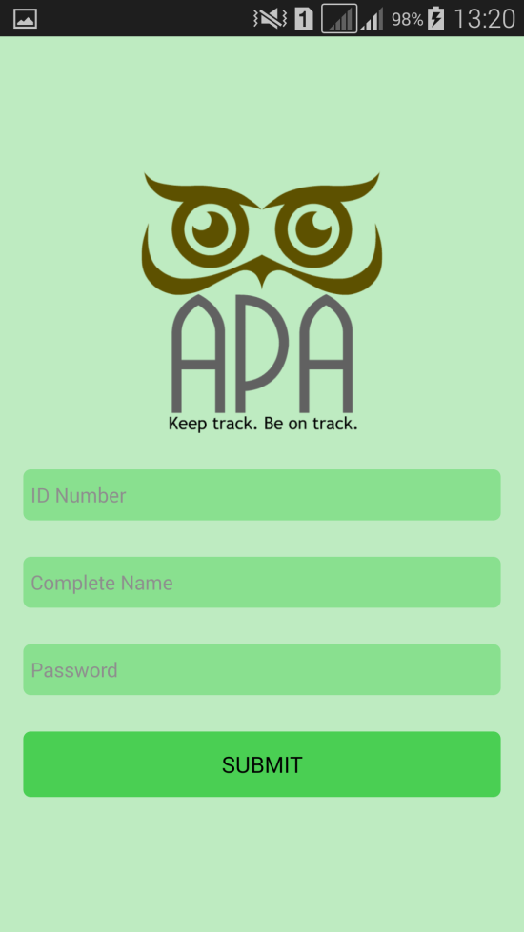 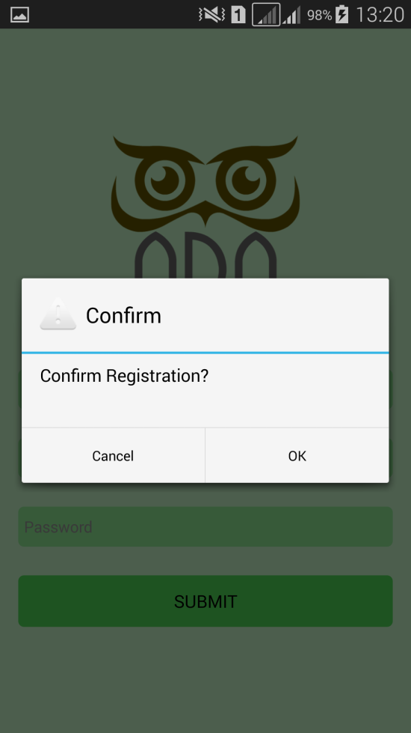

# **Navigation Drawer**

The application allows the user to conveniently navigate through different pages with the help of a navigation drawer.

The navigation drawer can be accessed by pressing the menu icon on the top-left corner of the screen.

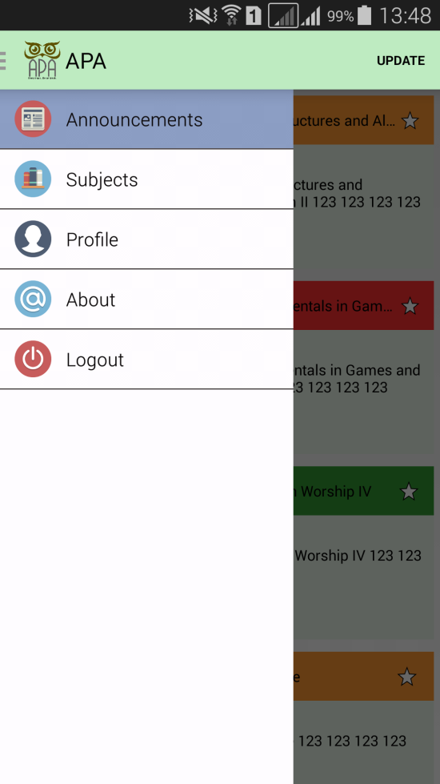

# **Announcements**

The Announcements page can be accessed through the Announcements option in the navigation drawer. The Announcements page contains a list of announcements from the school. Selecting an element on the list will redirect you to the full story of the announcements. The announcements can also be updated by pressing the menu option “Update”.

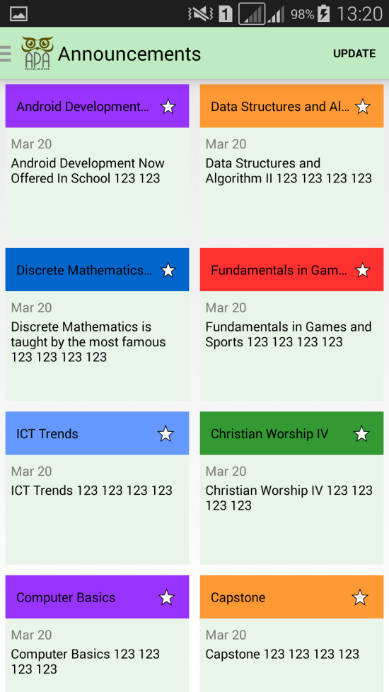 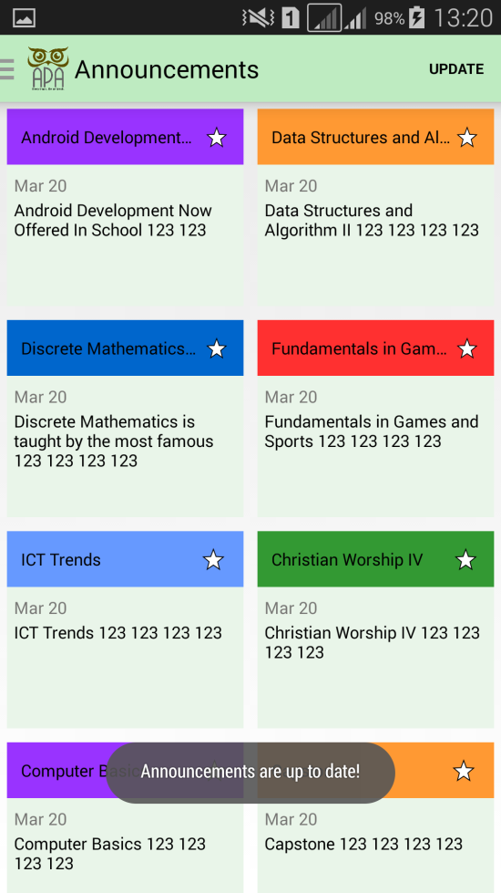

# **Specific Announcement**

The page can be accessed through clicking an announcement item from the Announcements page. It contains the full story of the announcement.

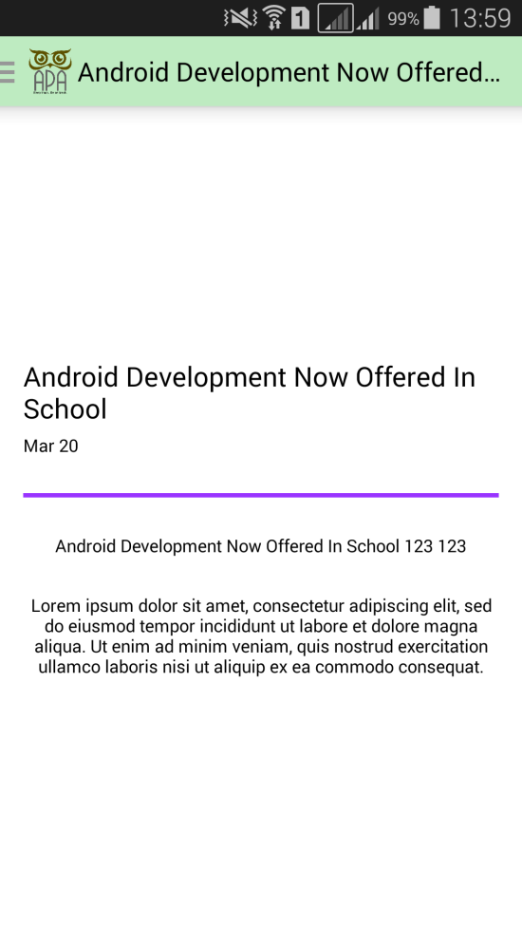

# **Subjects**

The Subjects page can be accessed through the Subjects icon in the navigation drawer. When a user logs in, he/she is redirected to the Subjects Page. The page displays the subjects of the user. When a specific subject is clicked it redirects to the specific subjects page. A new subject can also be added through pressing the menu option “Add”.

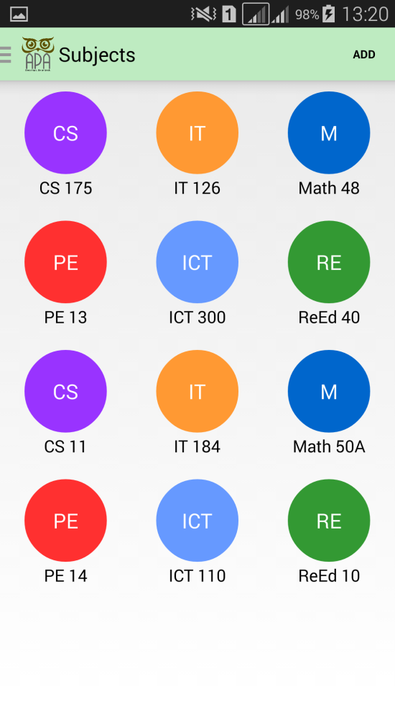

# **Add new subject**

The Add new subject page can be accessed by clicking the menu option “Add” in the Subjects page. It will contain a form to be filled by the user to add a new subject. Menu option “Submit” can be pressed to submit the inputted form values.

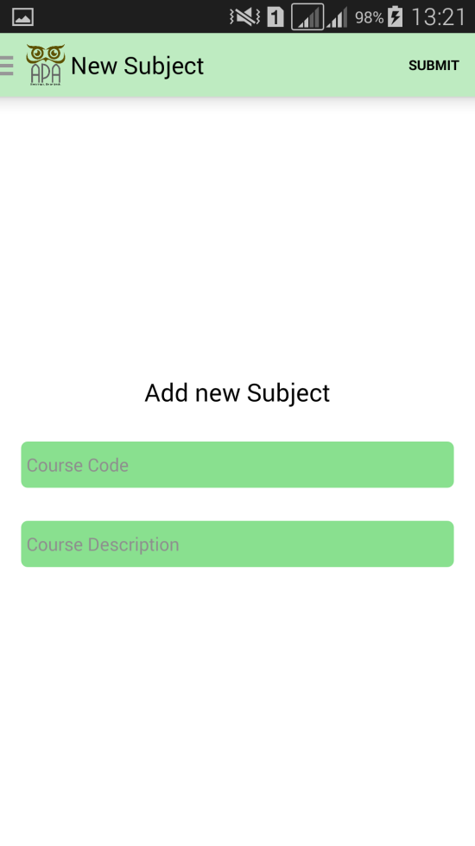 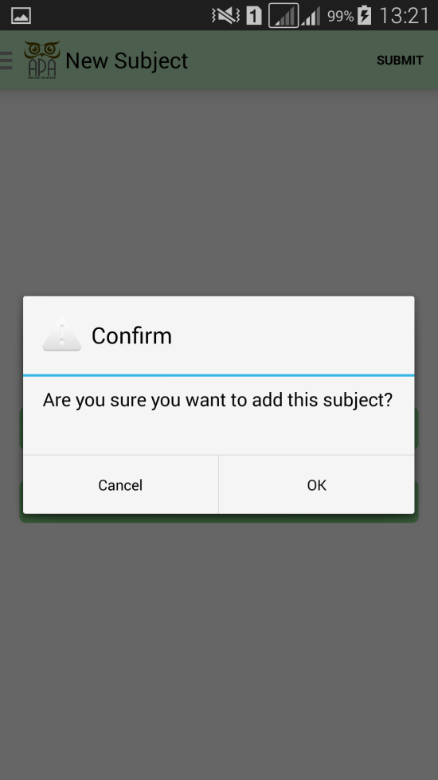

# **Specific Subject**

The page will contain the course logo, course name, course description and two buttons. “Grading System” button will redirect the user to the grading system page of the subject. “Items” button will redirect the user to the items of the subject.

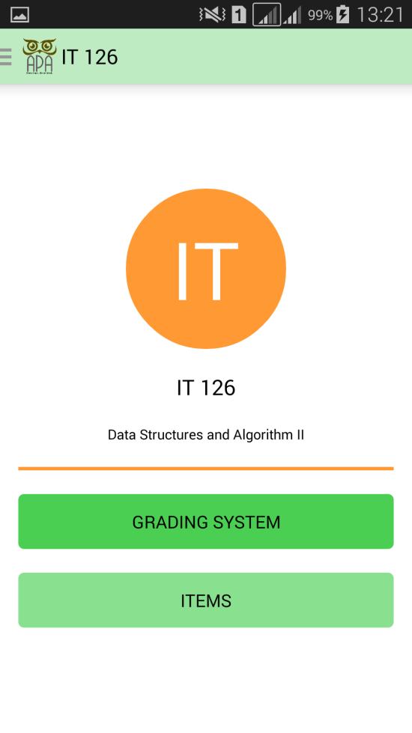

# **Grading System**

The Grading System page will show the grading system of the project. The grading system can be updated through pressing the menu option “Update”.

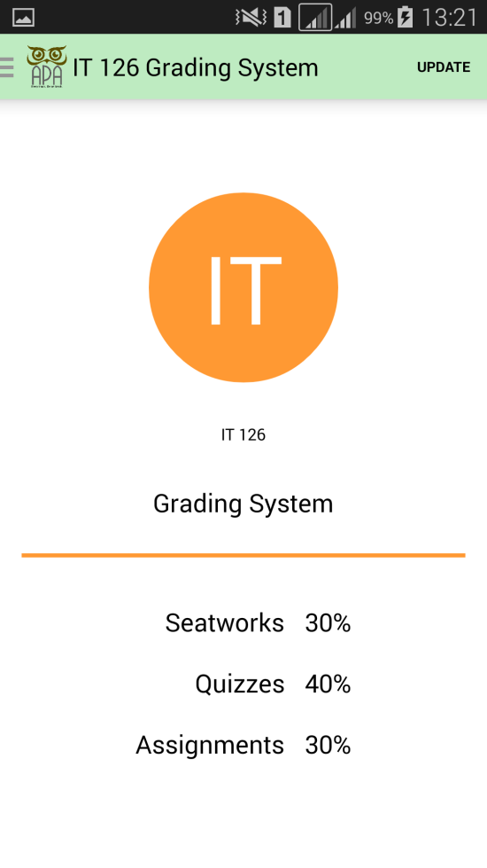

# **Update Grading System**

The page will display a form to update the grading system of the subject. The new grading system can be saved through pressing the menu option “Save”.

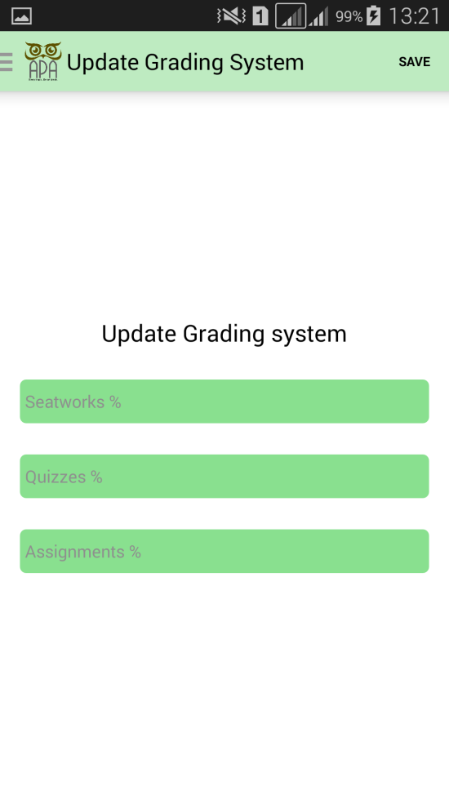 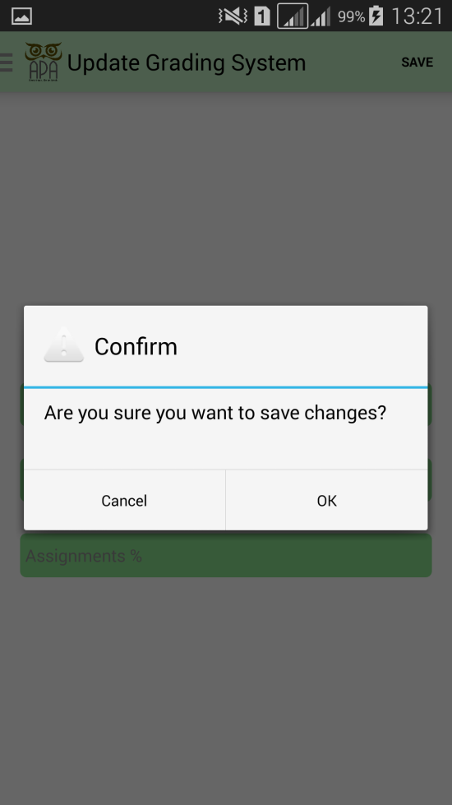

# **Items**

The page will display all the items of that subject together with their corresponding raw and total scores. A new item can be added through pressing the menu option “Add”.

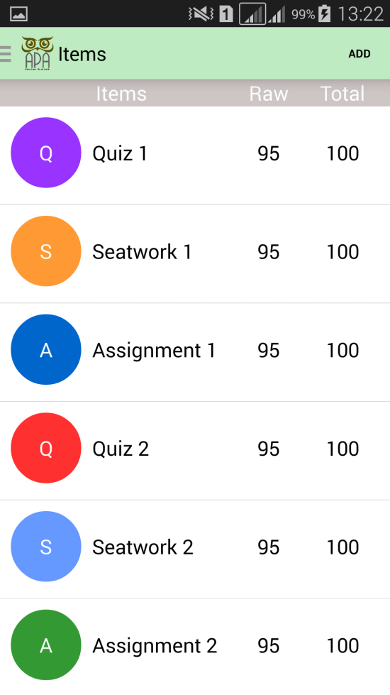

# **Add new item**

The page will display a form for the user to fill up necessary information about the item. The new item can be added through pressing the menu option “Submit”.

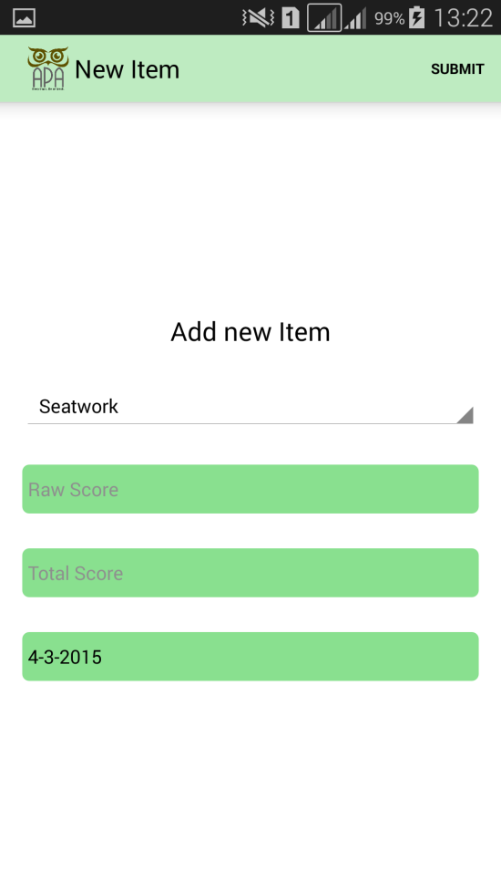 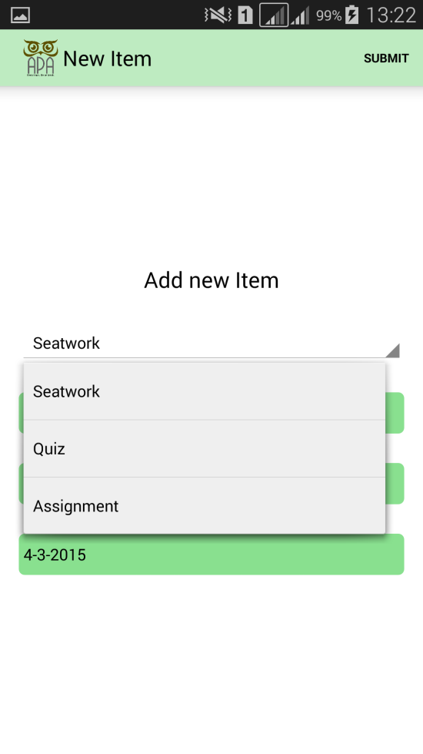 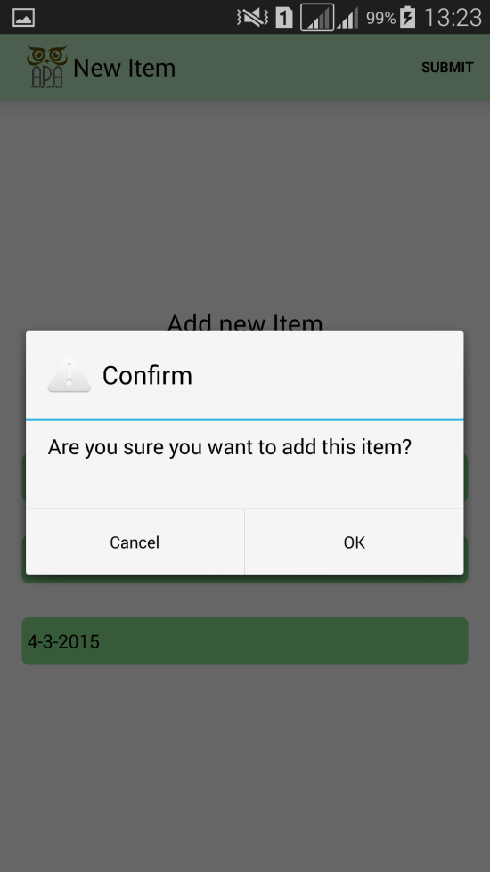

# **Specific Item**

The page will contain the item logo, item name, raw and total scores of the item. The scores can be edited through pressing the menu option “Edit”.

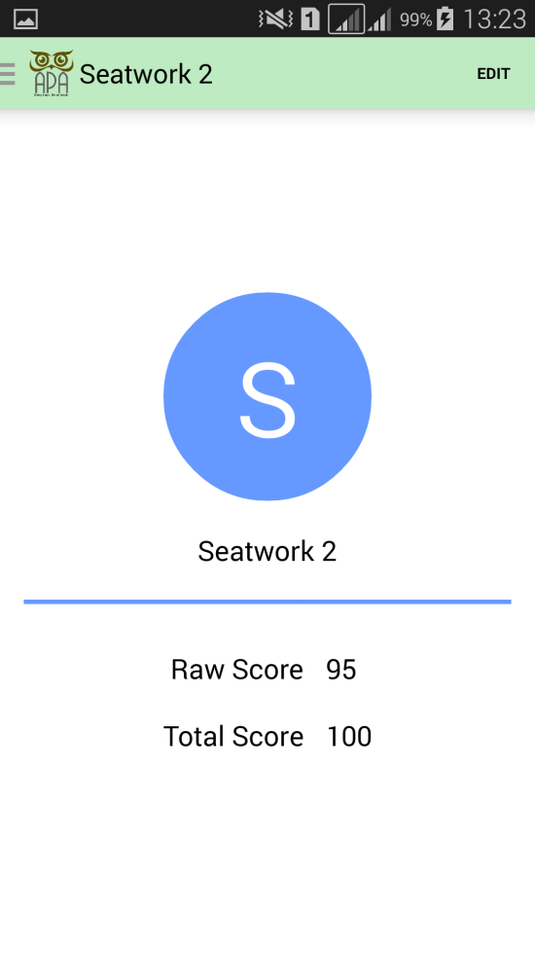

# **Edit item**

The page will display a form for the user to fill up necessary information about the item especially the new scores. The changes can be saved through pressing the menu option “Save”.

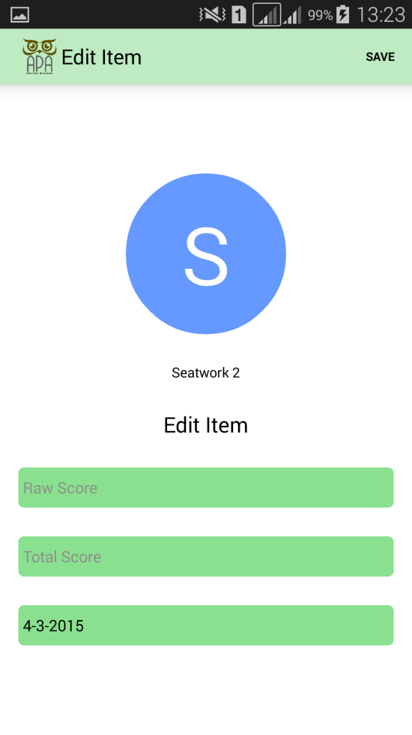 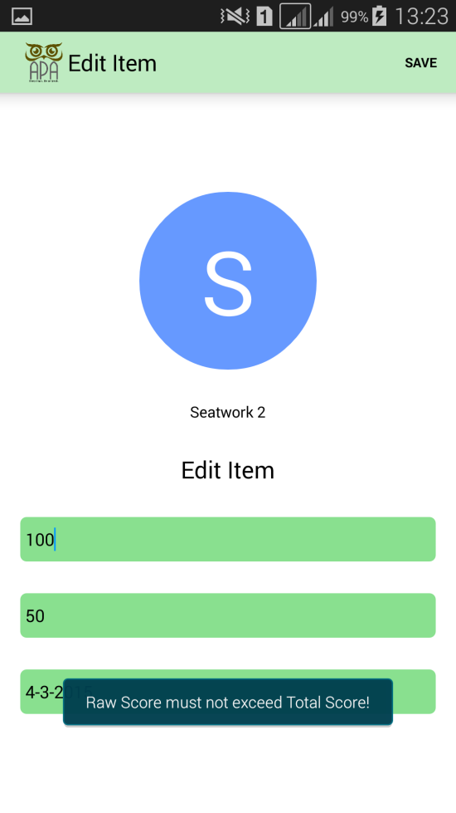 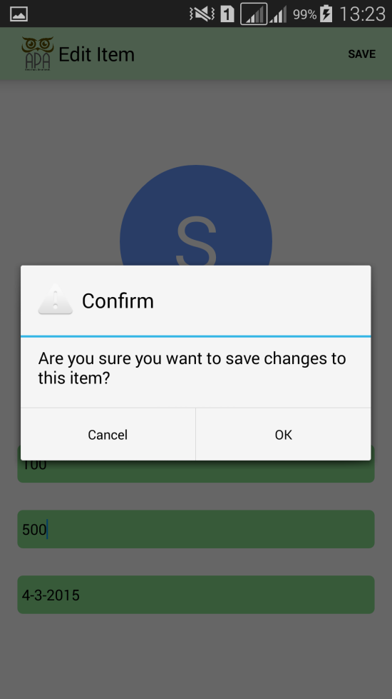

# **Profile**

The Profile page can be accessed through the profile icon in the navigation drawer. The page contains the photo, complete name, and the id number of the user.

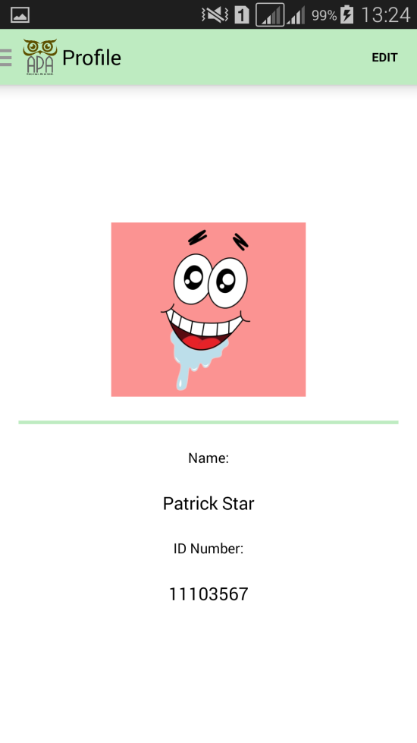

# **Edit profile**

The page will display a form for the user to fill up necessary information including the photo. The user can change photo through pressing “Choose photo” button. The changes can be saved through the menu option “Save”.

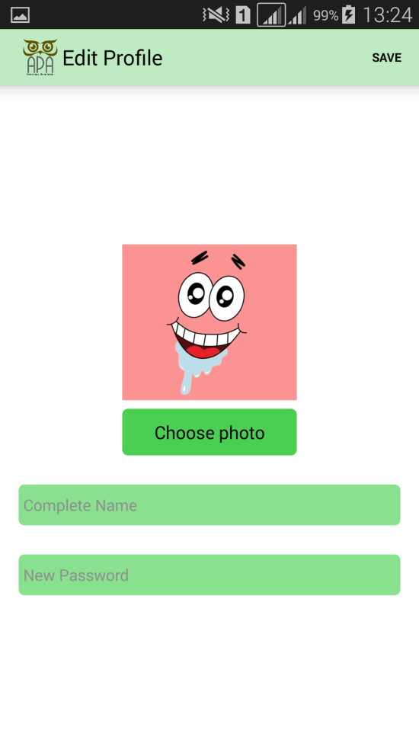 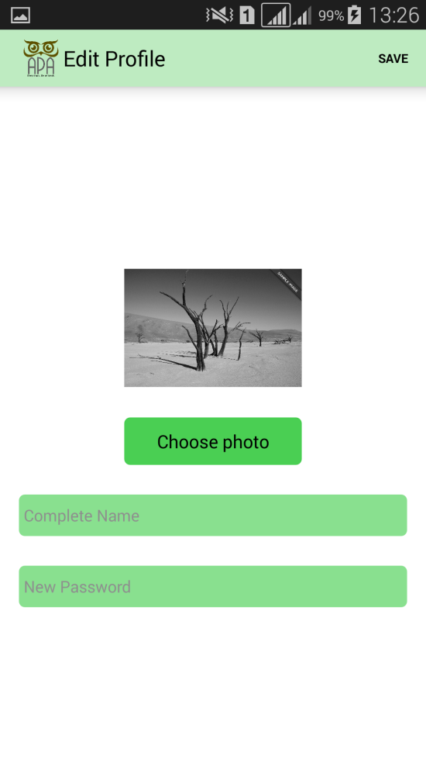 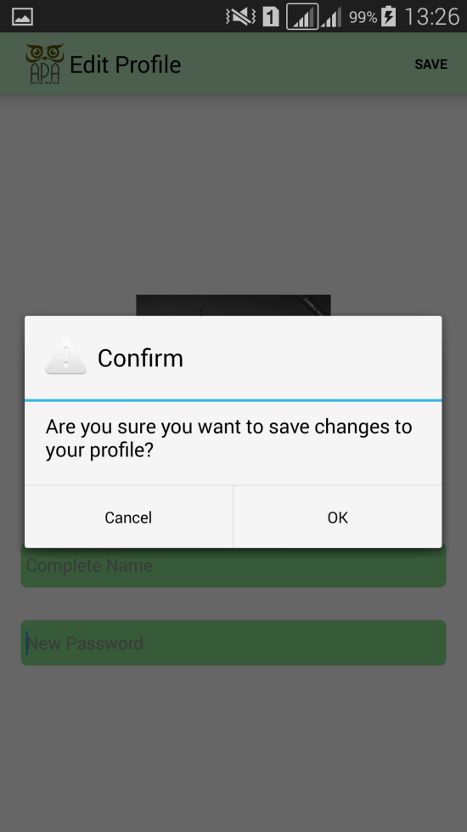

# **About**

The About page can be accessed through the about icon in the navigation drawer. The page contains information about the application and the developers behind it. The developers’ photo or name can be clicked to contact them.

 